Project Plan

<NSW Traffic Penalty Data Analysis and Visualisation Tool>

Zak Cobham-Davis, William Crane, Christopher Linnett

Table of Contents

1.0 Introduction 3

1.1 Background 3

1.2 Scope 3

1.3 Document contents 3

2.0 Work Breakdown Structure 4

3.0 Activity Definition & Estimation 5

4.0 Gantt Chart 8

Appendix A: Version Control System 9

Github Commit History 9

# Introduction

## Background

This report (Part A) is a structural breakdown of a two-part assessment, in this first part, a plan will be prepared that includes a project overview, work-breakdown structure, activity definition, and estimation as well as a Gantt chart for displaying and scheduling time estimation. Following this a software design document will be prepared for the NSW (New South Wales) Traffic Penalty Data and its related functionality requirements, it will include a system vision statement, the programs functionality requirements, use case documentation, software components, and the related software design, and a wireframe of the user interface (to be implemented in Part B).

Implementation of this structural report will occur in Part B, as the overall goal of the assessment is to develop a simple data analysis and visualisation tool for a dataset. Prior to the implementation of code, Part B will focus on the formulation of a testing plan to ensure the components within the system function correctly, these findings will be documented within a testing report. Furthermore, a user manual that explains the software and an executive summary that has analysed the data across a 12-month will be submitted alongside the final code. The final code will produce a graphical user interface that will handle the specific analysis and visualisation of NSW traffic penalty data, along with being able to complete specific analysis and visualisation tasks, one custom insight/analysis option for users to interact with will also be implemented.

## Scope

The purpose of this report is to analyse and visualise New South Wales (NSW) Traffic Penalty Data between 2011 and 2017. In the first part of this project, a project plan will be submitted, it will contain a project overview, work breakdown structure, Activity definition and estimation and a Gantt chart for displaying scheduling and time estimation. The deliverable tasks for this section of the Assessment is the Project Plan implementation and procession of this document and the software design document will occur throughout Part B of the Assessment. Part A’s project plan will be prepared utilising templates from a cloned GitHub Repo supplied via the course convenor.

## Document contents

The contents of the project plan include three main sections. the introduction, work breakdown structure, activity definition and estimation and a Gantt Chart. Section One (1.0) of the project plan contains an introduction to the assessment specifying the assessment background, scope and documentation contents. The introduction (1.0) is then proceeded by a work-breakdown structure (2.0) that provides an itemised list of features to be implemented into the program. Furthermore, section three (3.0) will contain activity definitions and estimates, which provide estimations for the activities that match the Gantt Chart displayed in section four (4.0).

# Work Breakdown Structure

The following work breakdown structure identifies tasks that will be undertaken from the point of accepting the project to delivering the completed project. The task will be broken up into five different categories; Preparation, Planning, Completing the Project Plan, Completing the Software Design Document, and finally Implementation and development.

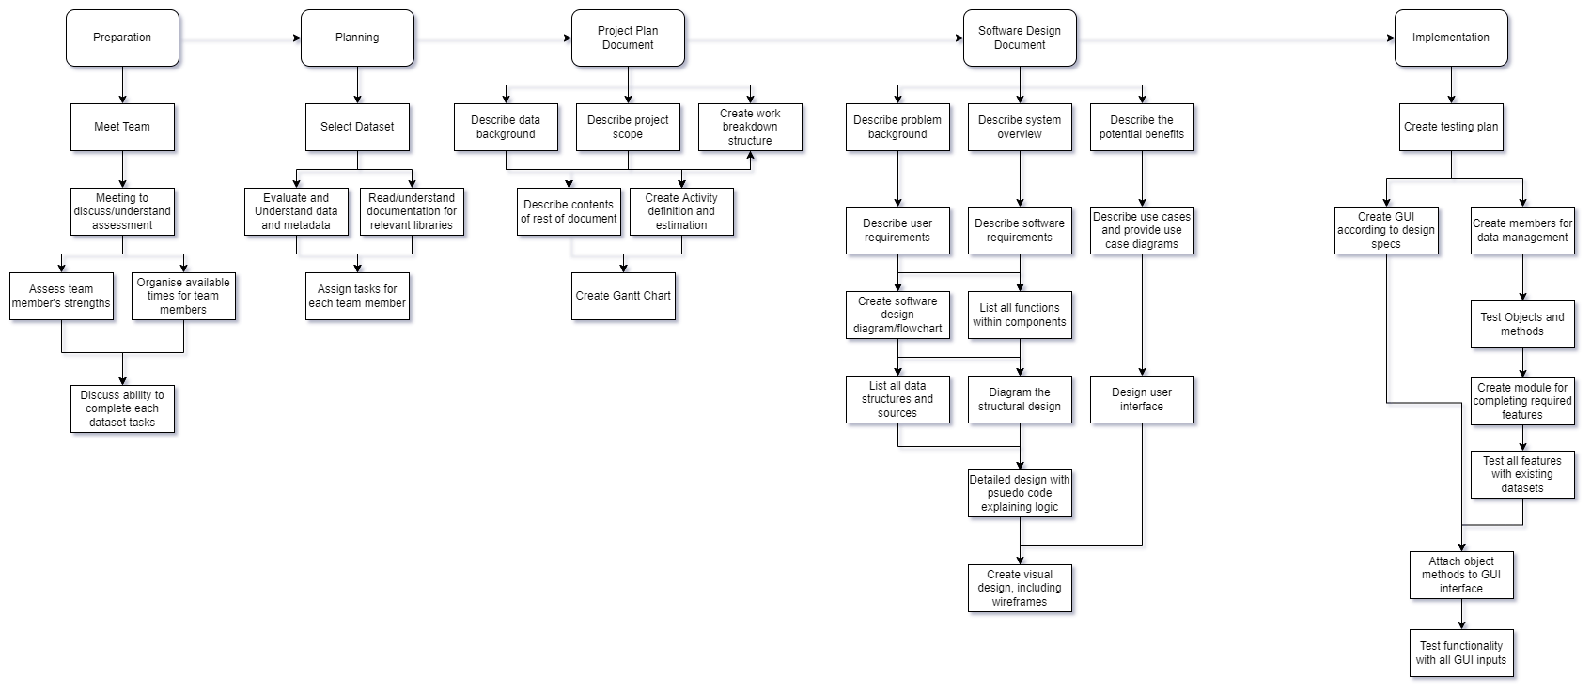

# Activity Definition & Estimation

The following highlights the tasks within each section of the work breakdown structure, the information is organised by title, allocated time to complete in working days followed by the definition.

|  |  |  |  |
| --- | --- | --- | --- |
| ID | Activity | Time(days) | Definition |
| 1 | Preparation | | |
| 1.1 | Meet Team | 1 | The team has introductions and gets to know eachother a little before focussing on work. |
| 1.2 | Meeting to discuss/understand assessment | 1 | The team goes over the assessment task and checks that each member has a similar understanding |
| 1.3 | Assess team member's strengths | 1 | Discuss which parts of the assessment each of us feel are within our own skillsets |
| 1.4 | Organise available times for team members | 1 | Write down days and times that we are available for having team meetings |
| 1.5 | Discuss ability to complete each dataset tasks | 1 | Evaluate each task and assess whether our own skillsets will allow us to be successful |
| 2 | Planning | | |
| 2.1 | Select Dataset | 1 | Team meets and agrees on the selected dataset and tasks associated with it |
| 2.2 | Evaluate and Understand data and metadata | 2 | Read through the data in the included dataset, make sure we understand what the columns are referring to and the way the data is communicated in each field. |
| 2.3 | Read/understand documentation for relevant libraries | 2 | Read documentation for required libraries, eg. Numpy, Pandas, Tkinter and try to understand which types of functions will be useful to the assessment. |
| 2.4 | Assign tasks for each team member | 1 | Communicate in a meeting which tasks each team member would like to take responsibility for. Distribute any remaining tasks once complete. |
| 3 | Project Plan Document: | | |
| 3.1 | Describe data background | 2 | As part of the introduction write some background information about the problem |
| 3.2 | Describe project scope | 1 | As part of the introduction write some background information about the scope |
| 3.3 | Create work breakdown structure | 3 | Create a work breakdown structure for the whole project. This will be consistent with the rest of the projects diagramming |
| 3.4 | Describe contents of rest of document | 1 | As part of the introduction describe the rest of the document |
| 3.5 | Create Activity definition and estimation | 2 | Utilising the work breakdown structure, for each task estimate the time required task and write a definition |
| 3.6 | Create Gantt Chart | 2 | Build a Gantt chart that matches the activity definition, this will also be submitted seperately |
| 4 | Software Design Document: | | |
| 4.1 | Describe problem background | 1 | Similar to the project plan, write a little about the background of the problem that this project is going to solve. |
| 4.2 | Describe system overview | 1 | Provide an overview of what the system will be able to do, how it will work and what information will be used. |
| 4.3 | Describe the potential benefits | 1 | Provide an overview of the potential benefits that this system can provide its userbase |
| 4.4 | Describe user requirements | 1 | Detail how a user is supposed to interact with and use the program. What the end user needs to do. |
| 4.5 | Describe software requirements | 1 | Detail the requirements for the software, ie the functionality it will provide. This will be listed formally. Can include both functional and non-functional requirements. |
| 4.6 | Describe use cases and provide use case diagrams | 3 | Through the graphical method of Use case diagrams, demonstrate some of the use cases achievable through the project. |
| 4.7 | Create software design diagram/flowchart | 2 | Create a class model diagram to show how the software will work. |
| 4.8 | List all functions within components | 2 | For each function in the software, describe what it does, what inputs it will accept, any effects it has on the rest of the system and a description of what the function returns. |
| 4.9 | List all data structures and sources | 1 | List the data structures in the software, for each data structure list the type, a description of where and how its used, its members and their purpose and functions that will use it. |
| 4.10 | Diagram the structural design | 2 | Create a diagram that will demonstrate the navigational and informational structure of the product. Support this with discussion and justification of design choices made. |
| 4.11 | Design user interface | 1 | Create the initial interface design, describe the tools used for the design stage and any findings that motivated this design. |
| 4.12 | Detailed design with psuedocode explaining logic | 2 | Create pseudocode for all the non-trivial/standard algorithms that operate on data structures. Describe the direct actions that methods/functions will take to complete their objectives. |
| 4.13 | Create visual design, including wireframes | 2 | Create wireframes and mockups that are supported by discussion and explanations for graphics, layout and other visual elements. |
| 5 | Implementation | | |
| 5.1 | Create testing plan | 2 | Create a plan involving the creation of tests for each class and member and interaction. |
| 5.2 | Create GUI according to design specs | 2 | Create graphical elements in Tkinter, build along the guidelines from the wireframe in the design document. Only include basic navigation between different screens, use a placeholder for the chart/report information currently. |
| 5.3 | Create members for data management | 1 | Build all the class files. For each of these classes create its properties and write its methods. |
| 5.4 | Test Objects and methods | 3 | Fill out documentation of all existing tests and what they are expecting as results, then evaluate each interaction to be certain there are tests in all possible cases. |
| 5.5 | Create module for completing required features | 3 | Build the module that will contain the methods for processing the main functions of the program. |
| 5.6 | Test all features with existing datasets | 3 | Repeat task 5.4, but include actual data in when testing. Build control tests where the expected results from the data can be predicted and compared. |
| 5.7 | Attach object methods to GUI interface | 2 | Assign the methods to the inputs and buttons on the GUI |
| 5.8 | Test functionality with all GUI inputs | 4 | Repeat task 5.6, but include occurrences for GUI input errors. |

# Gantt Chart

This gantt chart details all the tasks that are involved within the project. Starting with meeting the team, through to testing of the final product. The specific order these tasks must be completed in is demonstrated along with the goal timeline for start and end of each task.

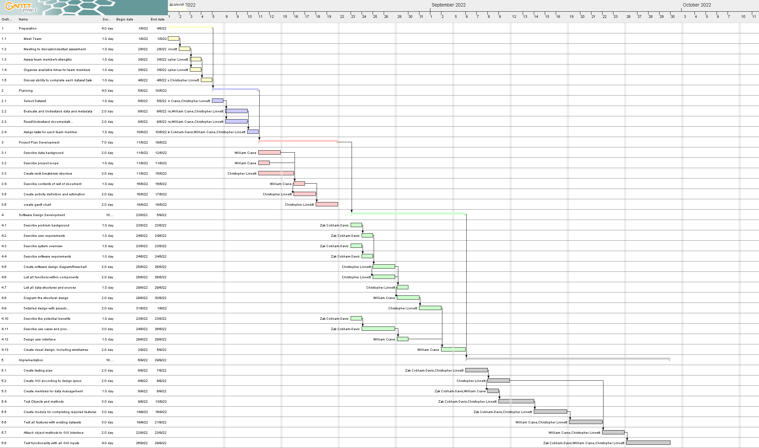

# Appendix A: Version Control System

The version control system to be used for documentation is mainly OneDrive as Git was found to be unreliable for tracking changes in word documents that are being collaboratively edited due to merge conflicts. OneDrive keeps track of every change made by any collaborator and was found to work much better in this context. Detailed below are the steps to view OneDrive “commits”:

1. Open the OneDrive folder containing the collaboratively edited files at: <https://griffitheduau-my.sharepoint.com/:f:/g/personal/zak_cobham-davis_griffithuni_edu_au/Em7nW5Sa-ddCj7D6RX0H3koBJgk2zbvyVRQcYYXqxs96HA?e=vzVEaU>  
   Right click on a document
2. Select “Version history”
3. You may then scroll through the document version history and open or download any previous versions and view who made the changes.

To note: OneDrive will need to be installed and signed into a Griffith University account

## Github Commit History

